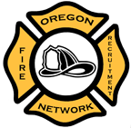
Oregon Fire Recruitment Network Agenda
April 20th, 2016
Location: Stayton Fire District

- Introductions
  - Name & Agency

- Minutes from last meeting

- OFRN Structure
  - Work Committee update (Bylaws)
  - SAFER Grant Application update

- Recruitment and Retention Matters
  - Open Forum
  - Survey Monkey
  - Sending letter to agencies re: funding etc. (Hector)

- Wrap Up: Next Meeting and follow up items

- Close Meeting

